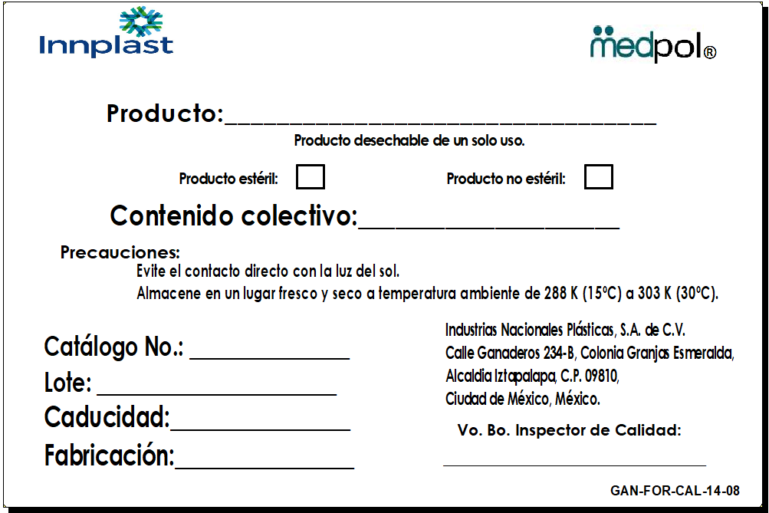
F6-PNO-FAB-13 (01)

